Any Document Names that contains any of the following words should be scrapped AND OCR’d:

1. “Application” or “Applications”
2. “Exhibit” or “Exhibits”
3. “Interested Parties” or “Interested Party”

**EXAMPLES:**

APPLICATION OF HEARING

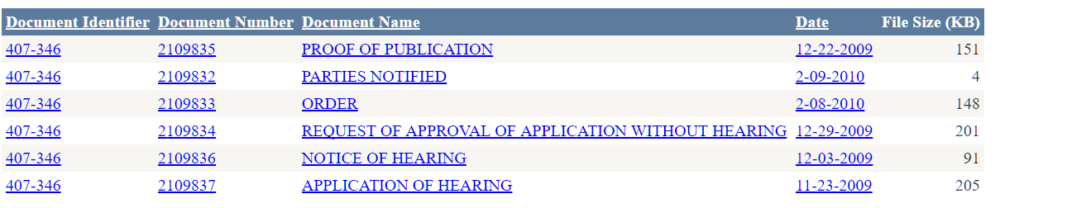

APPLICATION / AMENDED APP(S) & SUPPORTING DOCS

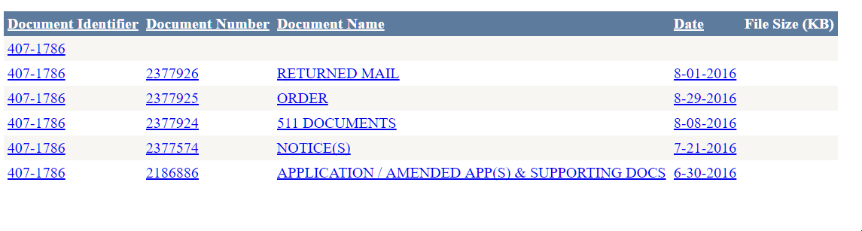

APPLICATION and EXHIBITS

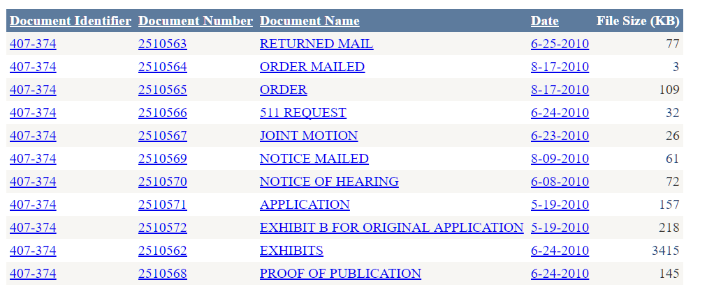

LIST OF INTERESTED PARTIES

